Keneally • Minnemann • Beller

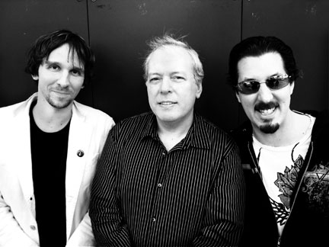
(l. to r.) Marco Minnemann (drums, vocals), Mike Keneally (guitar, keyboards, vocals), Bryan Beller (bass, vocals)

What if the word “supergroup” wasn't defined by the fame and egos of its members, but by the quality of the music they make? While Mike Keneally, Marco Minnemann and Bryan Beller dare to redefine that misused cliché, they're also happily retooling the expectations of their audience.

Keneally, Minnemann and Beller may not be household names, but they need no introduction among the tens of thousands who relish intense, exploratory live performances and musicianship so advanced it that seems somehow irrelevant in the face of their near-telepathic cohesion.

The three share an addiction to musical adventure, otherworldly chops and talent (tempered by refreshing humility), and a sly sense of humor. Now it's time to tour, they've decided, because playing together is always challenging, fun and unpredictable for them-- no two performances are ever alike.

Multi-instrumentalist, vocalist and composer Mike Keneally cut his teeth as the stunt guitarist in Frank Zappa's band. He's gone on to record well over a dozen of his own albums and appeared on dozens more by Zappa, Steve Vai, Henry Kaiser, Screamin' Jay Hawkins and many more. Keneally's talents are so powerful and varied that he can, with ease, record a sublime solo piano album, go on to write and perform a CD with Holland's Metropole Orchestra, then tour as guitarist for the animated satirical speed-metal band Dethklok. Perhaps the respected All Music Guide put it best: "With his wide-ranging talents and ability to be creative in almost any musical situation, Keneally is the leading progressive rock genius of the post-Zappa era."

Marco Minnemann is looked upon by his peers as one of the most innovative drummers on the international music scene today. He was recently profiled on the cover of the world’s foremost drum magazine, Modern Drummer, and is known for his amazing four-way independence. That skill, along with Marco's unusual drum kit set up (multiple foot pedals, a gong, electronics and unique cymbal configurations), helps him achieve ever-escalating musical heights. Marco's career began in his native Germany and has taken him on tours around the world with the likes of Nina Hagen, the Buddy Rich Big Band, Necrophagist, Terry Bozzio, and now, Keneally Minnemann Beller. He has also released acclaimed solo music and award-winning instructional books and DVDs.

Straight out of Berklee College in 1993, bassist Bryan Beller landed a gig with Dweezil and Ahmet Zappa’s tweaked rock project Z. Also on board was Mike Keneally, and in a lasting gesture of solidarity with his avant-garde pop/rock/fusion musical vision, Beller left Z when Keneally did in 1996. Over 12 years, seven albums, and countless tours later, their musical partnership continues to this day, strong as ever. Bryan has also found time to work and tour with luminaries like Steve Vai and Wayne Kramer, has released two lauded solo albums, and is a Contributing Editor for Bass Player magazine.

Keneally, Minnemann and Beller have played a few concerts before in California and Europe, but this is their first tour as a real band. "Bryan and I have worked together forever, and he's amazing at anticipating my every move," Keneally explains. "I've been playing with Marco for a much shorter time, but sometimes I feel like we were separated at birth. The three of us can create instant orchestration that's totally in line with what feels right to me."

It's a thrill to experience KMB in concert and catch their own unadulterated surprise and enjoyment over what's being jointly created-- one sign of a true supergroup.

###

Keneally Minnemann Beller: www.kmblive.com
Mike Keneally: www.keneally.com
Marco Minnemann: www.marcominnemann.com
Bryan Beller: www.bryanbeller.com

Management: Scott Chatfield, Obvious Moose Communications
1-760-753-7111
scott@obviousmoose.com

Europe booking: Pieter van Hoogdalem, PVH Music
Office: 31–(0)20-7710265
Mobile: 31-(0)6-26126221
pvh@pvhmusic.com

